**ESET-350-507**

*Final Project Report*

Device Chosen: Function Generator

Written by:

Coleman Beggs

**Overview:**

This product was a board which used a 9 V battery as a power supply as well as a 555 Timer IC device. A series of filters were used to filter the output wave of the 555 Timer into different waveforms. On the physical device a jumper was used to select the desired output wave; however, on this simulation, the behavior of the jumper was implemented with four switches to select the desired output wave. For the project, a physical board was assembled, but while measurements were being taken in the lab, the positive output pin was damaged and unable to be repaired. A simulation was then implemented to demonstrate the board’s behavior as well as obtain output plots.

Figure : Functional Block Diagram of Circuit

**Theory of Operation:**

There are a few key components to the design of this circuit. There is a timer configured in an astable mode to generate a square wave. This square wave is then fed into a series of passive filters. The outputs of these filters are selected by closing the circuit. There’s also a diode connected to the battery.

To start, the timer is configured in an astable mode. This is done by connecting the capacitor, C3, to the trigger as well as the threshold pin; this was done to keep the timer continuously generating a low and high signal. The 15 kΩ resistor, R7, was connected to the discharge pin. The power supplied to the IC along with the reset pin were connected to the output of the diode. The reset pin was connected this way to prevent a false triggering. Intuitively, the ground pin was connected to ground. For the astable mode to function properly the capacitor must be constantly charging and discharging. The charging/discharging on the capacitor allows the flip-flop inside the timer IC to toggle with a high and low signal.

Figure : 555 Timer Schematic

There are four different choices of an output waveform. These choices were implemented with switches on the simulation; each switch is labeled for the output generated when selected. The square wave is simple to obtain because the output of the timer is used in this scenario as seen in Figure 3. To obtain other outputs, the square wave is filtered. For this circuit, the filter is a fourth order passive filter in total. For the rest of the outputs, the square wave from the timer is ran through the passive filter. To obtain the Integrator wave, Figure 4, the output is connected only to first order section of the filter. Similarly, when the Triangular wave is selected, it is a second order filtered version of the original square wave. The wave isn’t perfectly triangular on its edges as seen in Figure 5. This leads to the sine wave seen in Figure 6 that is generated when the square is filtered to the fourth order.

Additionally, there is a flyback diode connected to limit the amount of reverse current because of the large signals being generated as outputs. A diode will only allow current to pass in one direction. This is especially apparent when viewing the collector current of Transistor 2 when the square wave was selected, shown in Figure 8. There was a peak-to-peak current swing of about 100 mA. Without the presence of the flyback diode, the battery would have to experience that amount of current, and this would cause damage to the 9V battery if the diode wasn’t there to stop the reverse current.

At the end of the circuit, the output of the selected wave was connected to a potentiometer. This potentiometer allowed for control of the amplitude of the output. To easily observe this phenomenon, the dial was rotated in lab before the physical device was damaged in lab.

Figure : Schematic for Signal Generator

**Simulations or Testing**

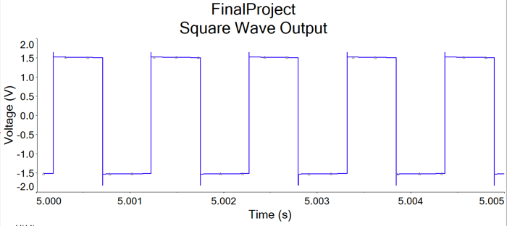

Figure 4: Square Waveform

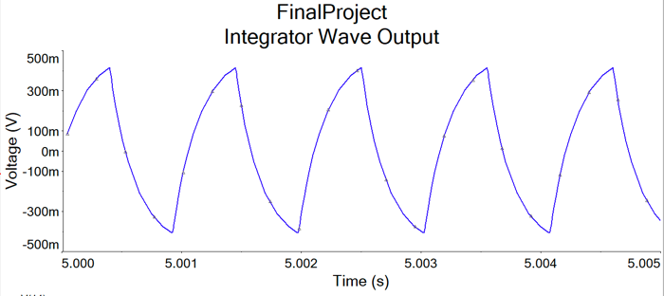

Figure 5: Integrator Waveform

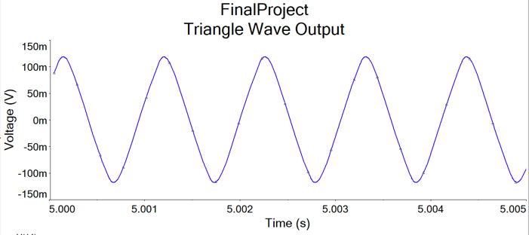

Figure 6: Triangle Waveform

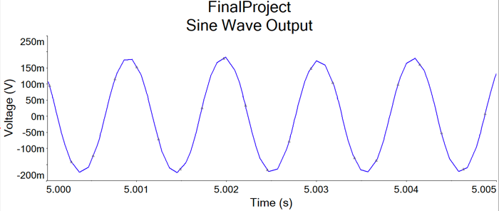

Figure 7: Sine Waveform

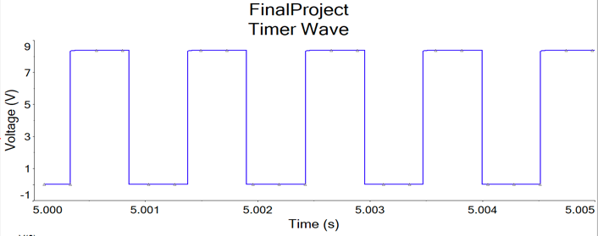

Figure 8: Timer Output Waveform

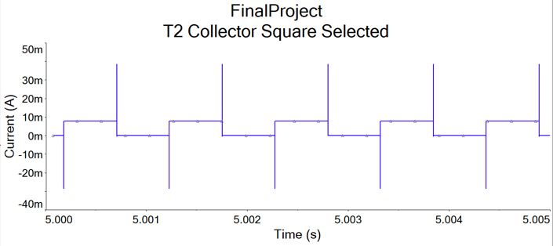

Figure 9: Transistor 2 Collector Current with Square Selected

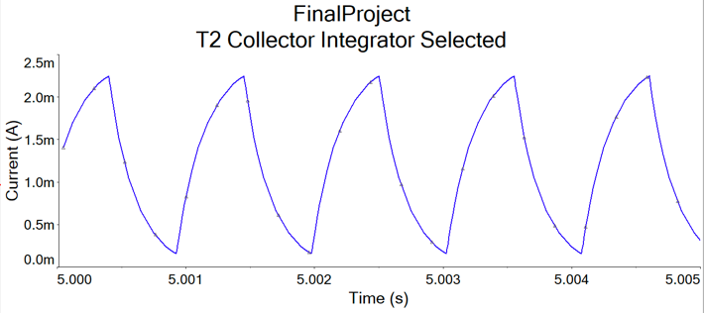

Figure 10: Transistor 2 Collector Current with Integrator selected

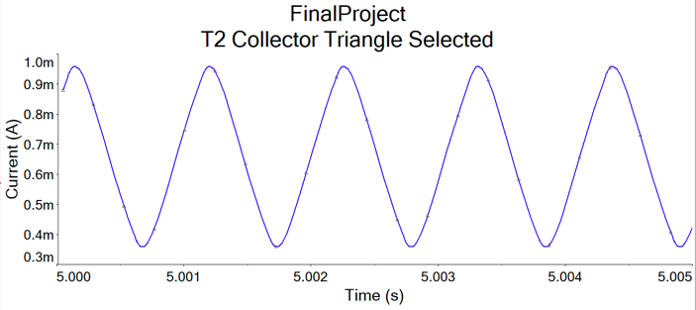

Figure 11: Transistor 2 Collector Current with Triangle Selected

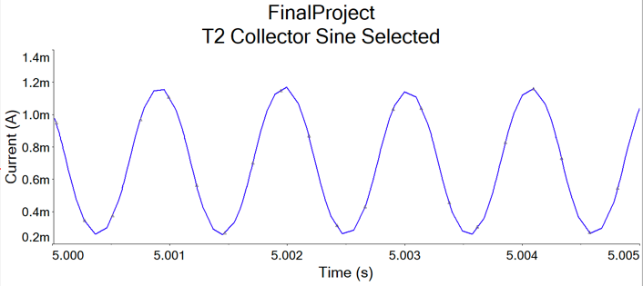

Figure 12: Transistor 2 Collector Current with Sine selected

**Conclusion:**

Signal generators can be made from using a simple timer. Using a series of passive filters, the square wave generated from the timer can be smoothed into a variation of waves. Each of these stages of the filter is one step closer to the desired sine wave. The sine wave output can be achieved after sending the output of the timer through a fourth order passive filter. To top off the control of the generator, there can be a potentiometer added at the end of the circuit to control the amplitude of whichever wave has been selected with a shunt jumper (actual device) or the switch shown in the schematic.

**References**:

* Admin. “What is 555 Timer IC – Working with Operating Modes”. WatElectronics. https://www.watelectronics.com/555-timer-ic-introduction-and-working-with-operating-modes/ (accessed April 23, 2021).
* Fonte, Gerald. “Making Waves”. Nuts and Volts. https://www.nutsvolts.com/magazine/article/making_waves (accessed April 20, 2021).
* Petrov, Petre Tzv. “Signal generator and Inverter Using NE555 Timers”. ElectronicsForU. https://www.electronicsforu.com/electronics-projects/signal-generator-inverter-ne555 (accessed April 22, 2021).
* Administrator. “What is a Signal Diode? V-I Characteristics, Types, Specifications”. Electronics Hub. https://www.electronicshub.org/signal-diode-tutorial/ (accessed April 24, 2021).